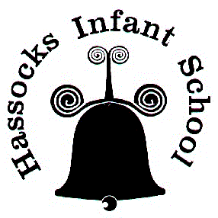 | Hassocks Infant School  National History Curriculum aims and objectives (Early Years and Key Stage 1)
EYFS: Knowledge and Understanding of the World
Understanding the world involves guiding children to make sense of their physical world and their community. The frequency and range of children’s personal experiences increases their knowledge and sense of the world around them – from visiting parks, libraries and museums to meeting important members of society such as police officers, nurses and firefighters. In addition, listening to a broad selection of stories, non-fiction, rhymes and poems will foster their understanding of our culturally, socially, technologically and ecologically diverse world. As well as building important knowledge, this extends their familiarity with words that support understanding across domains. Enriching and widening children’s vocabulary will support later reading comprehension.

Past and Present
Children will be able to talk about the lives of the people around them and their roles in society; - Know some similarities and differences between things in the past and now, drawing on their experiences and what has been read in class; understand the past through settings, characters and events encountered in books read in class and storytelling.

National curriculum purpose of study:
A high-quality history education will help pupils gain a coherent knowledge and understanding of Britain’s past and that of the wider world. It should inspire pupils’ curiosity to know more about the past. Teaching should equip pupils to ask perceptive questions, think critically, weigh evidence, sift arguments, and develop perspective and judgement. History helps pupils to understand the complexity of people’s lives, the process of change, the diversity of societies and relationships between different groups, as well as their own identity and the challenges of their time.
National curriculum aims:
- know and understand the history of these islands as a coherent, chronological narrative, from the earliest times to the present day: how people’s lives have shaped this nation and how Britain has influenced and been influenced by the wider world
- know and understand significant aspects of the history of the wider world: the nature of ancient civilisations; the expansion and dissolution of empires; characteristic features of past non-European societies; achievements and follies of mankind
- gain and deploy a historically grounded understanding of abstract terms such as ‘empire’, ‘civilisation’, ‘parliament’ and ‘peasantry’
- understand historical concepts such as continuity and change, cause and consequence, similarity, difference and significance, and use them to make connections, draw contrasts, analyse trends, frame historically-valid questions and create their own structured accounts, including written narratives and analyses
- understand the methods of historical enquiry, including how evidence is used rigorously to make historical claims, and discern how and why contrasting arguments and interpretations of the past have been constructed
- gain historical perspective by placing their growing knowledge into different contexts, understanding the connections between local, regional, national and international history; between cultural, economic, military, political, religious and social history; and between short- and long-term timescales.

