
Hassocks Infant School Reception Term: Spring 1 Spring
Week 1
Personal, Social & Emotional Development – being determined
Lesson 1  I can work as a team.  It is such an important skill to be able to work as a team, share ideas and begin to find a compromise.  Build something together, this could be a model made out of blocks, Lego, Duplo, or a junk craft, but work as a team with your child to create something. Encourage them to put forward their own ideas but also suggest some of your own. Keep going when it gets tricky and talk about how you can adapt and change things to try again or keep persevering.  If you have differing ideas, encourage your child to talk it through and come to an agreement that will make you both happy. | Lesson 2  Read and share the story of ‘The Tortoise and the Hare’.  Think of something they have done that they found tricky to start with but with practice and never giving up they managed to do it. Provide a couple of examples like learning to walk, riding a bike.  Talk about what they had to do to make sure that they succeeded. Talk about, like the tortoise, it doesn’t matter about speed – it is the keeping going that is important!  Think about something you might want to get better at and are going to be determined to succeed in – set yourself a challenge! | Lesson 3  I can keep going with activity, even when it gets tricky.  Developing the skills to complete an activity and feeling the success of your end result is really important.  Try and…  - colour a complete picture  - complete a puzzle  - play a memory game (e.g. pairs) until you have found them all  - a fun idea is to make a tower using spaghetti and marsh mellows!  Finishing the other activities for your remote learning will also help this too! | Lesson 4  I can learn to never give up!  Have you ever tried something new and given up because it isn’t as easy as you’d hoped?!  We all have! Join Jaime in the Zen Den as she explains how to keep going. We learn what a GROWTH MINDSET is - and how it helps us all push through that tricky phase of learning when we want to give up. Anyone can do it! Jaime also shares her top 5 five tips for using a GROWTH MINDSET for when things get really challenging...  Use the link for the free trial to access some great activities to develop your growth mindset!  https://cosmickids.com/watch/?tax=video_category&term=mindfulness

Communication and Language – listening, responding appropriately and asking questions
Lesson 1  I can listen carefully and talk about things I have learned.  Choose an episode of ‘Maddie’s Do You Know?’ that you are interested in to watch.  https://www.bbc.co.uk/iplayer/episodes/b09yn3ly/maddies-do-you-know  Listen VERY carefully to the information that she is telling you about and after, talk about it together to show that you have heard, understood and remembered new information. | Lesson 2  I can listen carefully and respond appropriately.  Choose an episode of ‘Maddie’s Do You Know?’ that you are interested in to watch.  https://www.bbc.co.uk/iplayer/episodes/b09yn3ly/maddies-do-you-know  After the episode, ask your adult to ask you some questions about what you have just seen – did you manage to understand and learn the information to become an expert in your chosen topic? | Lesson 3  I can listen carefully and ask questions to find out more.  Choose an episode of ‘Maddie’s Do You Know?’ that you are interested in to watch.  https://www.bbc.co.uk/iplayer/episodes/b09yn3ly/maddies-do-you-know  Having listened carefully to what Maddie has told you, can you think of questions you would like to ask her to find out more information?  Try and think of a question that starts with each of our key question words:  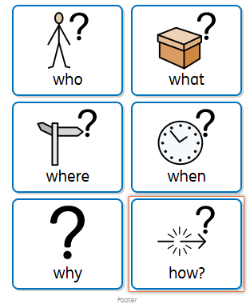 | Lesson 4  I can talk about something that I am interested in.  Think about something that you know lots about – it could be a favourite animal/toy/TV programme etc, a hobby/sport/game, or something that really interests you.  Have a go at thinking about what it would be interesting to tell your friends all about. You might want to draw/cut out pictures or use photos a prompts. Practise talking to your family about your chosen topic and then get them to ask you questions about it after!  If you would like, you could film your talk, just like Maddie and add it to Tapestry so we can show your friends!

Physical Development
Lesson 1  I can strengthen my pincer grip.  Making your pinching finger and thumb stronger will really help your mark making and pen control.  Playing with play dough is a great way to build up strength in your fingers. Try squeezing, splatting, pinching and rolling with ‘Dough Disco’ activities from Early Years Emily  https://www.youtube.com/playlist?list=PLOcPymb-OvBy6NN-nkIHG4eXNC_mksrAx  You can also strengthen your pincer grip by hanging things up with pegs, threading, using tweezers or tongs, or popping bubble wrap. | Lesson 2  I can begin to form my letters.  Practise writing some of our letters using the correct formation. Try to encourage the tripod pen grip.  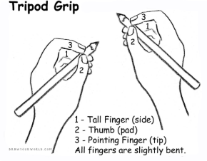  Each of these letters starts at the top. | Lesson 3  I can use scissors safely.  Make sure that you are holding your scissors and paper correctly (your thumb on each hand should be pointing up) - remember … ‘Thumbs up!’  Try and practise your cutting skills by cutting along different types of line. Start by drawing and then cutting along straight lines, then make them wiggly, then zigzagged. Make sure you cut away from your body so that you are safe.  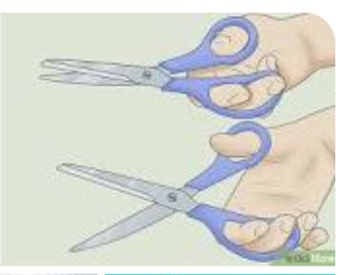 | Lesson 4  I can move my body in different ways.  Take part in your own PE lessons by following Jump Start Jonny’s dance or movement lessons.  https://www.jumpstartjonny.co.uk/free-stuff  See if you can copy the different movements he does. Talk about how it makes you feel and what is happening to your body when you’re doing the movements. Can you feel your heart beating faster? Can you feel your body getting warmer?  Have a go at coming up with some of your own movements to some songs now.
   |  | 
  Slither down the snake | Around the apple and down the leaf | Down the tower, up the stairs and across the tower.
   |  | 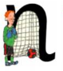
  Down the pirates plait, back up and around his face | Down the insects body and a dot for its head. | Down Noddy and up and over his net.

Reading and Phonics  Try and tick off as many of these activities as you can each week as part of your home learning! Colour in the circles each time you complete the activities.  Reading  Share a book each day; Start by looking at the pictures and then making predictions about what you think is going to happen, who the main characters are etc. Next, follow along the words with your finger as an adult reads. Make sure you go left to right, top to bottom each time. Can you spot any tricky words you know? Have a go at sounding out some of the words with sounds you know. Sound talk it first and then blend it together – what does it say? Lastly, asking and answering questions and retelling (using key events, in order) afterwards will help show you have understood what the book has been about. Talk about what exciting vocabulary you heard – can you have a go at using it in a sentence?    Song of Sounds  Practise singing the Song of Sounds Stage 1 song every day.  https://www.youtube.com/watch?v=48uf9I6P2xQ  Play a different phonics game each day  - Make or print cards with CVC words and matching pictures e.g. dog, cat, man, hat, tap, hen, net, peg, sun. Hide them around the house for children to go and find, can they match the pictures to the words?  - Play initial sound games, can children hear what letter sound a word starts with? Give children a letter sound – can they go and find something in the house that starts with that specific letter. E.g. ‘b’ – bottle, bear, brush  - Find a selection of objects, can children sort the objects into groups by what sound they start with? Words that rhyme?  - Say a word, can children have a go at writing the letters for the sounds that they can hear – draw and label a picture, write a list (shopping, activities to do, songs for Alexa to play!) write a card to a friend to say hi! | Wellbeing  Improve your wellbeing by taking part in mindful activities.  Watch videos on GoNoodle on different ways to be mindful  https://family.gonoodle.com/channels/flow  Practise mindful breathing, mindful colouring or mindful eating.
Number
Get to know the numbers 1, 2, 3, 4 and 5 really well and ways to make each number.

Can you put the numbers in order?

Can you say what number comes next or comes before?

Watch Numberblocks ‘Whole of me’ to explore further parts of numbers and how we can record these in number sentences. https://www.bbc.co.uk/iplayer/episode/b08dr1l3/numberblocks-series-1-the-whole-of-me

Can you remember all the pairs of number to make each e.g. 0 and 4, 1 and 3, 2 and 2, 3 and 1, 4 and 0 all make 4
Explore these using objects (small toys, pasta, fingers), drawings, songs
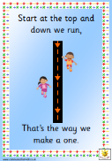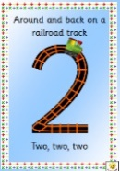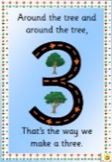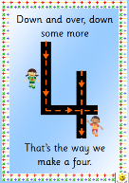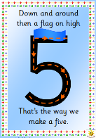
Choose a different number each day and explore all the parts that can go together to make it. Record your ideas in pictures, with objects or number sentences.

Week 2
Personal, Social & Emotional Development – being determined
Lesson 1  I can work as a team.  It is such an important skill to be able to work as a team, share ideas, take turns and begin to find a compromise.  Can you and your child work together as a team to complete a puzzle? Encourage your child to take turns with the pieces and let you put some in as well.  Can you share ideas about how to start your puzzle? Do you start with the outside edges first or start with a feature point of the puzzle?  Share ideas and work together – and don’t give up until you complete it (even of this is in sessions over a few days!). | Lesson 2  I can keep going with an activity, even when it gets tricky.  Developing attention and concentration takes practise, try to regularly choose one of the activities and work on increasing the amount of time that you can focus and complete it.  Try…  - Spot the difference games  - Copy a picture  - Playing Kim’s Game  - Playing ‘I went to the supermarket…’  (See below) | Lesson 3  - I can talk about my feelings  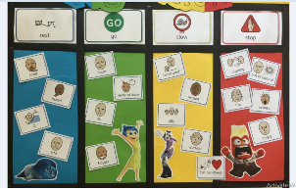  Larger version on next page!  Look at the Zones of Regulation that we have learned about and some of the feelings we might have in each zone.  Think about a time when something has been really tricky and you have had to keep trying, but it wasn’t going well – what zone did you go into? Blue? Red? What could you do next time to get back to green and keep on trying? | Lesson 4  I can talk about my feelings.  This week, focus on different feelings. Watch the videos of the Trace Moroney books “When I’m feeling…”  https://www.youtube.com/watch?v=mIdPjMIYGrA&list=PL5dXaswkmgBludj1qDx0oohFBxyJlvVXQ  With each video, discuss the feeling and if there is ever a time you or your child have felt that way. It’s good for them to know that you can feel that way as well. Talk about ideas for how to feel better if you are feeling upset, angry, jealous or scared. Where do these feeling come in the Zones of Regulation)? Add these to your feelings, and any strategies, to display to the display poster. For you to put up at home and help keep you regulated!
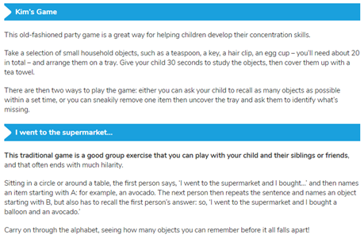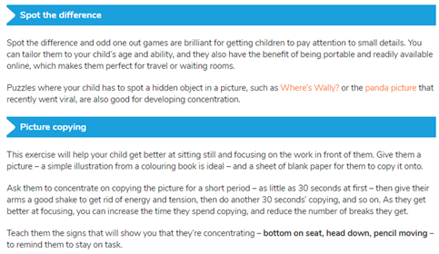

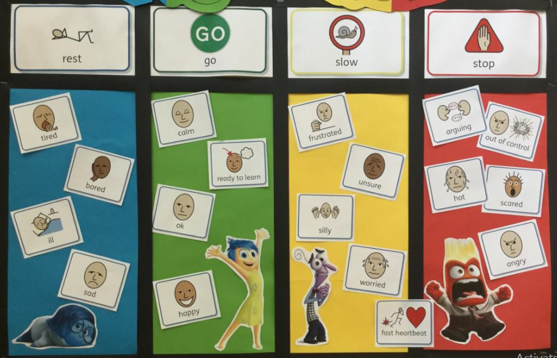
Communication and Language - listening, responding appropriately and asking questions
Lesson 1  I can hear rhyming words  Find some items around the house or print picture cards of things that rhyme e.g. cat, bat, hat; dog, log, frog.  Play silly soup together. Have a bowl and a spoon and sing the song together:  “I’m making lots of silly soup,  I’m making soup that’s silly,  I’m going to cook it in the fridge  To make it nice and chilly  In goes a fox… a box… some socks”  Start with the objects or picture cards you have and then see if your child can come up with their own rhyming words to add. These can be nonsense words as long as they still rhyme. | Lesson 2  I can follow instructions  See if you can follow 3 to 4 given instructions at a time. These might be familiar routines to start with e.g. go and put on your pyjamas and then brush your teeth and finally brush your hair, or for different tasks e.g. get a bowl and spoon, next put the cereal in the bowl then add the milk.  Give your child instructions to create a picture. Draw a simple picture yourself first, such as a house, an insect or a flower. Then give your child step-by-step instructions of how to draw it without them seeing your picture. They need to make sure they are listening carefully to follow your instructions. At the end, reveal your pictures and see if they look the same. | Lesson 3  I can ask questions  Create a game of guess who with members of your family, friends or characters from books, films, or TV.  Model asking questions, describing the person or character and encourage your child to do the same. E.g. do they have long, brown hair? Are they tall?  Can you work out who the other person was thinking of?  It would be helpful to have photos of the people or characters you are using, either on a screen or printed out. | Lesson 4  I can follow instructions  To help practise your instruction following, fine motor skills and get crafty – have a go at using the instructions from Mister Maker to make a project of your choosing.  https://www.bbc.co.uk/cbeebies/shows/mister-maker  Send us some pictures of your creations on Tapestry!

Physical Development
Lesson 1  I can talk about ways to be healthy.  Talk with your child about what it means to be healthy and to look after our bodies and minds.  Discuss different ways to help to keep your body healthy - drinking water, exercise, good night’s sleep, and good hygiene. Talk about these things and track them throughout the week – which ones are you good at? Which ones could you try and improve to make you even healthier and happier!  Why not make a poster of all the ways you know about how to be healthy to help teach others about it! You can add labels and captions too, to make it even better! | Lesson 2  I can begin to form my letters.  Practise writing some of our letters using the correct formation. Try to encourage the tripod pen grip.  These letters, apart from ‘d’, all start from the top. | Lesson 3  I can use scissors safely.  Make sure that you are holding your scissors and paper correctly (your thumb on each hand should be pointing up) - remember … ‘Thumbs up!’  Try and practise by cutting different materials to make a collage a collage (foil, paper, card, bubble wrap) etc. The more you practise the easier it will become!  Look at what happens when you pull the materials tighter – does it get easier or harder to cut?  Show us a picture on Tapestry of what you make with your super cutting skills! | Lesson 4  I can move in different ways.  Take part in your own PE lessons by playing these movement games. Clear some space in the living room or play in the garden.  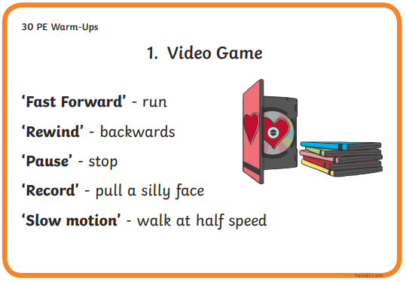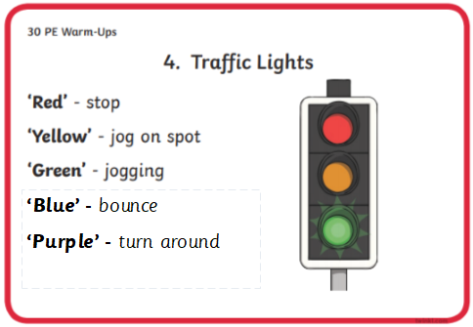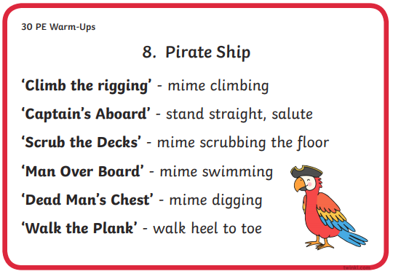
   |  | 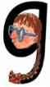
  Down Maisie, over the mountain, over the mountain. | Around the dinosaurs bottom, up its long neck and down to its toes | Around the girls face and down her hair with a curl
   |  | 
  All around the orange | Curl around the caterpillar | Down the kangaroos body, up and around its tail and kick out its leg

Reading and Phonics  Try and tick off as many of these activities as you can each week as part of your home learning! Colour in the circles each time you complete the activities.  Reading  Share a book each day; Start by looking at the pictures and then making predictions about what you think is going to happen, who the main characters are etc. Next, follow along the words with your finger as an adult reads. Make sure you go left to right, top to bottom each time. Can you spot any tricky words you know? Have a go at sounding out some of the words with sounds you know. Sound talk it first and then blend it together – what does it say? Lastly, asking and answering questions and retelling (using key events, in order) afterwards will help show you have understood what the book has been about. Talk about what exciting vocabulary you heard – can you have a go at using it in a sentence?  Song of Sounds  Song of Sounds  Practise singing the Song of Sounds Stage 1 song every day. This week really focus on the digraphs/trigraphs at the end of the song – can you remember the 2/3 letters that make those sounds?  https://www.youtube.com/watch?v=48uf9I6P2xQ  Play a different phonics game each day  - Go on an object hunt around the house for things that have got digraphs in e.g. fork, train, sheep, chick, ring, green, tree, coin, book, food etc.  - Make digraph cards and use these and the objects to play sound games - can children sound out the word and hear what digraph is in it?  - Can they match the object and the digraph it contains?  - Write the words, to match the objects you have found, on cards – can you count, blend and read the word to match them up?  - Say a word, can children sound out the word have a go at writing the letters for the sounds that they can hear? | Wellbeing  Improve your wellbeing by taking part in mindful activities.  Watch videos on GoNoodle on different ways to be mindful  https://family.gonoodle.com/channels/flow  Practise mindful breathing, mindful colouring or mindful eating.
Number
Part, part, whole – Can children separate the numbers in different ways?
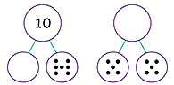
Roll a dice or use number cards, then have a go at finding as many ways to make the number as you can, recording with PPW diagrams.

Shapes
Listen to and sing songs to help you learn the names of 3D shapes (Using Google, search ‘3D shape song’ for lots of options!)
- Go on a hunt around the house – can you find objects that are a sphere, cylinder, cube, cuboid, pyramid etc.
- Talk about the properties of the shapes – how many edges/faces/vertices do they have?
- Have a go at sorting the objects you found by number of faces/if faces are curved or flat etc.

