
Hassocks Infant School Year - 1 Term - Spring 1

Week 1
Maths – Number and Shape, Space & Measure
Lesson 1  We are learning to describe and sort 2D shapes.  Remind yourself of the 2D shapes we have learnt by singing this song.  Once your brain is warmed up, watch this video. You will be describing 2D shapes, classifying them into two groups and sorting them independently using this sheet. To finish off, see if you can answer the questions in the quiz at the end of the video!  Challenge:  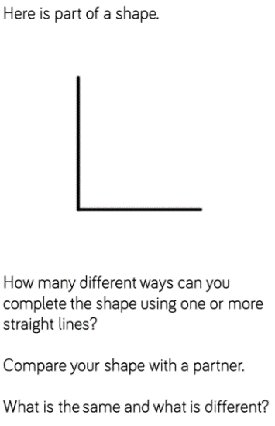 | Lesson 2  We are learning to recognise and name 3D shapes.  Recognise and learn your 3D shapes by singing this song.  After listening to the song, see if you can match the 3D shape to its name using the attached sheet (Week 1 day 2).  Challenge: Can you find the 3D shapes around your house? Can you collect cuboids, cones, cubes and sphere? Now try the activity 2 sheet.  To finish off answer this true or false question and explain your answer.  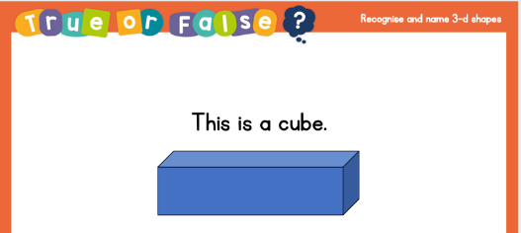 | Lesson 3  We are learning to sort 3D shapes.  Can you remember the shapes from yesterday? Test yourself using the Day 3 PPT attached.  Challenge: Find some 3D shapes around your house. Can you sort them by the ones with corners? How about the ones with curved faces? Can you put all the shapes with 4 faces together?  Now think of your own way to sort them.  If you don’t have objects that are 3D shapes try this game instead.  Finish your learning by completing the challenges on the attached sheet (Week 1 Day 3) | Lesson 4  We are learning to make patterns with 2D and 3D shapes.  Can you solve this true or false question? Challenge: Can you explain how you know? E.g. I know this because…  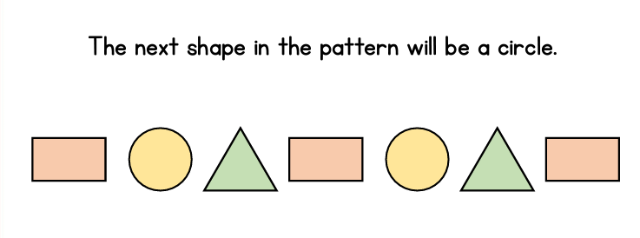  Work through the games on here to learn about shape and pattern.  Complete the challenges and complete the patterns with 2D and 3D shape found on the attached sheet (Week 1 day 4).

Writing
Lesson 1  We are looking at diaries in this unit of work.  We are learning to listen to a recount.  You will be creating a recount map.  Watch this video lesson.  You will need; a piece of paper or an exercise book, a pencil or a pen, and your brilliant brain.  Practise spelling the tricky words: I, my, today, of, me, so, of, was, where. Which parts are tricky?  Listen to the recount and have a go at draw the main events in the story.  Challenge: Use your story map to tell someone else the story. | Lesson 2  We are learning to tell a recount from memory.  Watch this video lesson.  You will need; a piece of paper or an exercise book, a pencil or a pen and your brilliant brain.  Listen to the recount again and use your recount map to help you step the text.  Challenge: Can you tell someone your recount without using your story map to help you? | Lesson 3  We are learning to use the past tense.  You will be listening to the recount, discussing the past tense, doing some shared writing and then having a go at an independent past tense task.  Watch this video lesson.  You will need; a piece of paper or an exercise book, a pencil or a pen and your brilliant brain.  Join in with the shared write and then try changing the sentences into the past tense.  Challenge: Can you write your own sentences using the past tense? | Lesson 4  We are learning to retrieve information.  Watch this video lesson.  You will need; a piece of paper or an exercise book, a pencil or a pen and your brilliant brain.  Practise spelling the tricky words: I, my, today, of, me, so, of, was, where. Which parts are tricky?  Read the questions, looking for keywords. Scan the text and find the information.  Challenge: Write down your thoughts and feelings in a diary for someone else to read.

Reading and Spelling  Try and tick off as many of these activities as you can each week as part of your home learning! Colour in the circles each time you complete the activities.  Reading  Aim for 20 minutes per day:  Mon Tue Wed Thur Fri  Spelling  Aim for 20 minutes per day:  Revise the rhymes for the vowel digraphs (ay, ai, a-e/ ea, ee, ey, e-e, y/ igh, ie, I-e) using the Song of Sounds mat.  Go on a word hunt and find them around the house in books or magazines.  Use Phonics play to practise alternative spellings for these sounds. (Scroll down to 5c-alternative spellings)  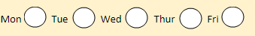 | Understanding of the World – History – Changes within living memory  This term we have been learning about old and new toys.  Watch this short video lesson about old and new toys.  Using a sheet of paper, divide it in half on one side make a list or draw and label all the new toys you can think of.  Now chat to your adults at home or grandparents. What toys did they have when they were your age? Perhaps you could go even further back in time and find some toys children played with in Victorian times.  Extension:  Can you make a cup and ball toy like the one shown below. Maybe you can challenge your family to see who can get the ball in the cup the most times.  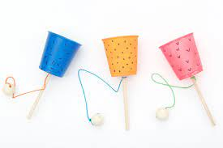 | Handwriting  We are learning to write pre-cursive easy letters.  Using your letterjoin link from the school office, practise your easy letters each day using the Year 1 lead ins.  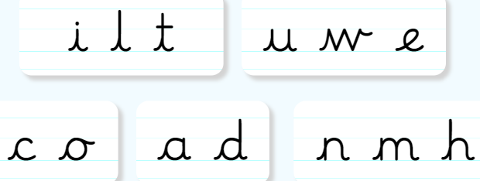
Creative Task –
We are learning to explore a range of toys.

Have a look at some of the toys in your home. This can include teddies, cars, dolls or something you have made! What materials can you see and feel? What do you think is inside them?

Have a think about which toy is your favourite. Why do you like it? What is it made from?
Draw a picture of your favourite toy and use a ruler to label it, naming the materials.

Challenge: Can you think about how you would improve your favourite toy to make it even better?

Physical Activities
We have been learning some gymnastic techniques using flight.
Can you show someone in your family how to do a tuck jump, straddle jump, star jump, pencil jump half turn and full turn jump?
Create a sequence using as many of these as you can. Maybe you can draw your sequence for someone else to follow. Remember to have a starting position and an ending.

Mon Tue Wed Thur Fri
Week 2
Maths – Number and Shape, Space & Measure
Lesson 1  We are learning to count forwards and backwards within 20.  You will need a pencil, some paper or the worksheet provided, some items to help you count.  Let’s warm up by singing this song to count to 20!  Watch this video and complete the questions.  Write these numerals in words: 14 17, 13, 12, 15, 18 and 20.  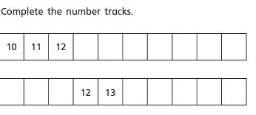  Challenge:  Look at these numbers. Which is the odd one out and why? 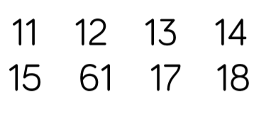 | Lesson 2  We are learning to represent numbers from 11 –20.  You will need a pencil, some paper or the worksheet provided and some items to help you count.  Warm up by singing this song and counting forwards and backwards to 20.  Watch this video and complete the table below.  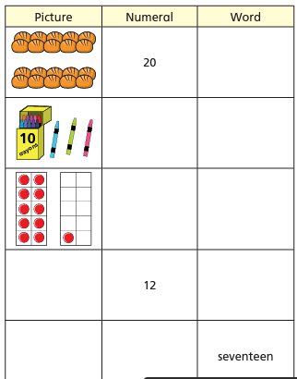  Challenge: Use objects around your house to make numbers from 11-20. You can use buttons, pasta or even make a tall tower using Lego! | Lesson 3  We are learning to identify numbers to 20 by counting 10 and counting on.  You will need a pencil, some paper and items to help you count.  Start by warming up your brain and singing this song to remind you of numbers 11-20.  Watch this video.  Challenge:  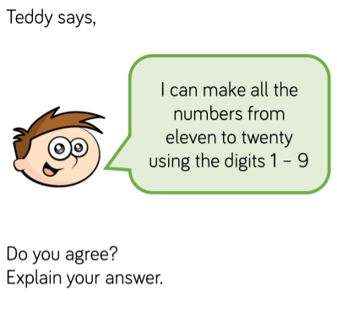 | Lesson 4  We are learning to find one more and one less than a number within 20.  You will need a pencil and some paper.  You will be exploring one more and one less on a number line and representing one more and one less in different ways.  Join in with the brain teaser on this video and then continue watching until you reach the independent task.  Challenge: 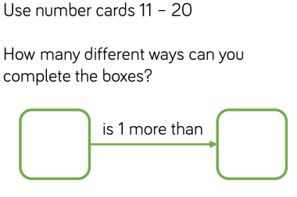

Writing -
Lesson 1  We are learning to box up for a recount.  You will be retelling with a recount map and then boxing up your recount.  You will need paper or an exercise book, a pencil and your brilliant brain.  Watch the video lesson.  Practise spelling the words; today, happy, where, care, lunches, funny, when, cats.  Have a go at boxing up your recount using pictures and words. | Lesson 2  We are learning to identify features of a recount.  You will be playing a game, sharing a read, exploring a text and building a toolkit.  You will need paper or an exercise book, a pencil and your brilliant brain.  Watch the video lesson and have a go and finding the features of a recount using the text.  Challenge: Can you tell your own recount to a family member, using these features? | Lesson 3  We are learning to write a recount. (Part 1)  You will be practising spellings, retelling the recount and completing a shared write before doing your independent task.  You will need paper or an exercise book, a pencil and your brilliant brain.  Watch the video lesson.  Practise spelling the words; happy, where, care, lunches, funny, when, cats.  Have a go at writing about the first event in your recount.  Challenge: Read your recount so far to a family member and using the toolkit from last lesson to check you haven’t missed anything! | Lesson 4  We are learning to write recount.  (Part 2)  You will be retelling the recount, completing a shared write and doing your own independent writing.  You will need paper or and exercise book, a pencil and your brilliant brain.  Watch the video lesson.  Have a go at writing a sentence, using your senses to describe the second event in your recount.  Challenge: Write one or more sentences to describe.

Reading and Spelling  Try and tick off as many of these activities as you can each week as part of your home learning! Colour in the circles each time you complete the activities.  Reading  Aim for 20 minutes per day:  Mon Tue Wed Thur Fri  Spelling  Aim for 20 minutes per day:  Revise the rhymes for the vowel digraphs (oa, oe, o-e, ow/ oo, ew, ue, u-e) using the Song of Sounds mat.  Go on a word hunt and find them around the house in books or magazines.  Use Phonics play to practise alternative spellings for these sounds. (Scroll down to 5c-alternative spellings) | Topic / Understanding the World  Science – Materials  Watch and listen to Materials song.  Now watch the video lesson about materials.  How many different materials can you name? Go on a materials hunt around your house making a tally chart of all the different materials. Which is the most common?  Find some socks, a plastic bottle and some keys. Identify which material they are made from. Why do you think each object is made from that material?  Which material is best to make a window? A table? Why?  Challenge:  Find an object at home and decide which material it is made from. Why do you think it is made from that material? | Religious Education - Christianity  Our big question this term is – Why do Christians believe Jesus is a good friend?  Who might we help or be friendly towards whom society does not treat well (e.g. homeless)?  What could we do to show friendship to people that we either don’t know very well or whom we are not naturally drawn to be friendly towards?  Make a poster to show how we can show friendship to others.
Creative Task - DT
We are learning to design our own soft toys.

Have a look at some of your soft toys. What do you like about them? What would you change?

You are going to design your own soft toy using felt. What animal will you choose? What colour? How will you decorate it and what will you use?

Draw your design and label it, using a ruler.

Challenge: write a list of resources you will need to make your soft toy.

