Hassocks Infant School
Weekly information for Parents and Carers - Weekly Overview
Year group: 1
Date: WC. 4.5.20
Dear parents/carers,
Hope this week sees you all safe and well. We can’t believe we are already in May! You are all doing an amazing job!
This fortnight’s theme for decorations is rainbow butterflies! Here are some pictures to inspire you:
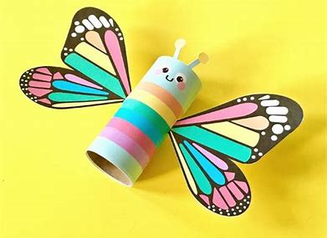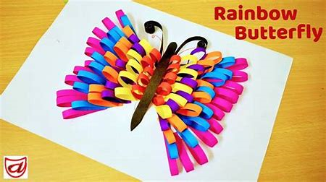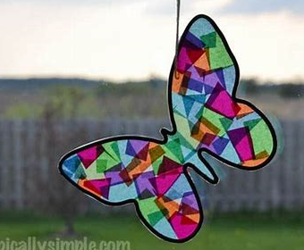
Please use this week’s home learning suggestions in whatever way suits you and your family. We understand as the weeks go by it can become more difficult to keep to a routine. Just remember sometimes ‘good enough is good enough’! Some days home learning can be successful, other days getting your children dressed is an achievement!
We hope you are enjoying our videos and finding them helpful to explain new concepts and set up the learning tasks for your children. Remember that the website has all the additional resources you should need, however, if there is anything else you need we here to help so please don’t hesitate to email and we will respond as soon as we can.
Seeing all your lovely learning really is a highlight of our days so please keep sending us emails of all the things that you are doing. When you return to school there will be a big display outside the Year 1 classrooms that will show off all of your home-learning achievements.
We will continue to keep in touch with you all to catch up on what you are doing and will try and let you know roughly the days when we will be calling. Please let us know if a specific day works better for you. We will be phoning every 2 weeks but please email in the meantime.
Stay safe, stay happy, stay you!
Best wishes,
The Year 1 Team.
Emails:
apple@hassocksis.com
ash@hassocksis.com
chestnut@hassocksis.com

