Hassocks Infant School
Weekly information for Parents and Carers - Weekly Overview
Year group: 1
Date: WC. 4.5.20

What will we be learning this week?
Area of learning | What are we learning? | Possible activities and ideas
Communication & Language and Literacy  (English) | Non-chronological report writing | Activity 1  Listen to Mrs Hutchinson reading about a pond creature and write down 3 or more facts that you found out.  Activity 2:  Find out about frogs! Use the internet or non-fiction books to find out all you can about frogs. Think about what they eat(diet), where they live (habitat) and what they look like (appearance). Write a few sentences about each thing. You could add pictures with captions to help explain what you have found out.  Activity 3:  Using everything you found out to write a non-chronological report about frogs. There are some templates on the website to help you understand what it needs to look like.  Challenge – could you make a non-chronological report about another animal or maybe a hobby or sport? Have a go at using the same template to make a report about anything you are interested in. Maybe phone a friend and work together to make a non-fiction book about something you both enjoy. Or you could make a video or Powerpoint report about an animal.  If you would like some extra writing practice, look at this lesson on: https://www.bbc.co.uk/bitesize/articles/zkgyvk7 and practice using capital letters and full stops in sentences.  You could also play Karate cats on https://www.bbc.co.uk/bitesize/topics/zd63xyc/articles/zdp4pg8 to practice spelling and punctuation online.
Mathematical Development | To make doubles  To make equal groups | Activity 1- Children- have a look at the problem below. Can you use your reasoning and problem-solving skills to solve the question below?  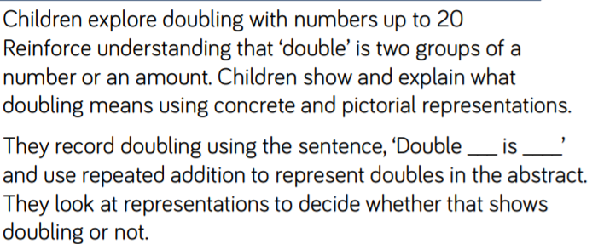  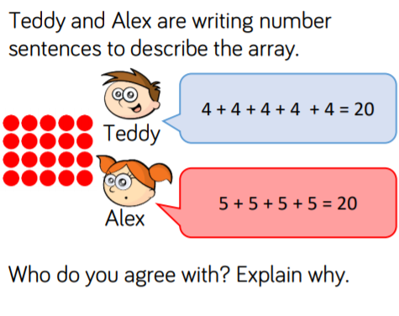Parents- 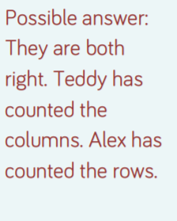  Activity 2- Parents-  See video- recapping doubling.  See – Miss Griffin’s challenge video  Double game- parents you may wish to write down the numbers 1-20 on paper and cut them out individually into number cards- or see number card print out.  Parents- you may wish to use practical resources to support your children with this activity  Children- select a card, can you double the number you have chosen. Can you record it in a sentence- ‘double___ is____’? Can you challenge yourself and record it as a number sentence as well?  Extra challenge- see problem solving sheet attached.  https://www.youtube.com/watch?v=4U2QLjqripY- doubles song!  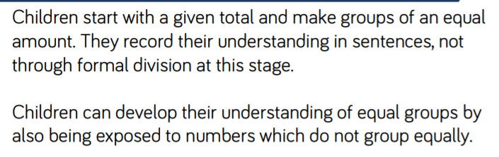  Teddy Bears picnic! -  Parents- you may wish to set the problem below out with teddy bears and food to make the problem more ‘real’ for the children  We’re having a picnic and I have 20 biscuits; can you practise making equal groups with the biscuits and complete the sentences below?  Can you complete the sentences below?  I can make ____ equal groups of 2  I can make ____ equal groups of 5  I can make ____ equal groups of 10  Challenge- What would happen if there were 21 biscuits?
Personal, Social, and Emotional Development.  - PSHE and Relationships (Jigsaw Time) | To identify what being a good friend means to me  To know how to make a new friend | In this session, we are going to explore friendship.  Parents with your child/ren- suggest names of pairs of characters they know from story books, movies or TV who are good friends and get on well together. Explore these a little: why do they get on well? Do they always get on? Do they ever disagree or fall out with each other? What do they enjoy doing together? Explain to the children that, to have good friends, we need to be a good friend.  Show children image below-  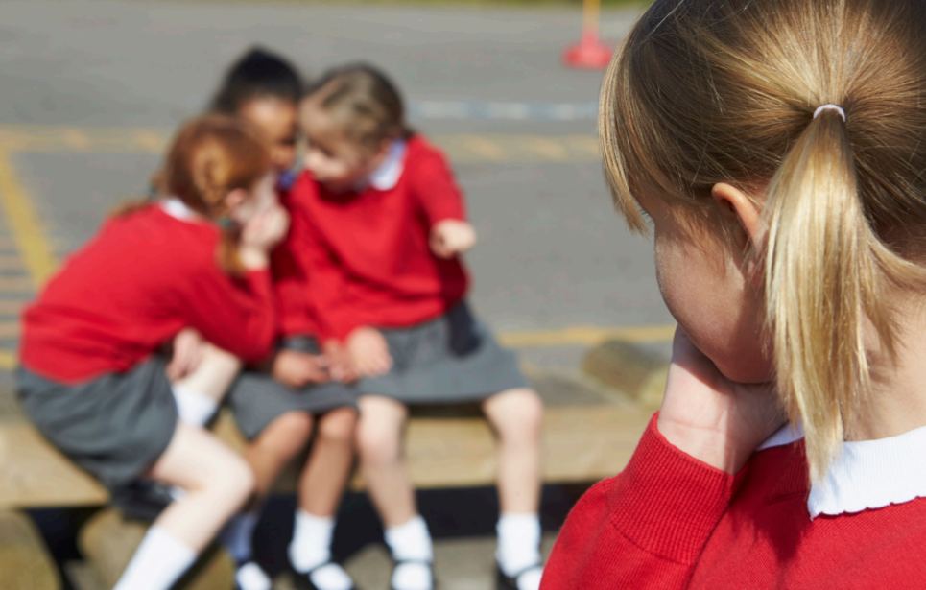  This is an image of the child alone at play time. Why do you think the child in the picture is alone? Draw out that they could have fallen out with their friends, they could be new in school, or they might be feeling poorly or upset. Explain that sometimes people have to move away from their old friends/school, so it might be frightening to be in a new school where they don’t know anyone. Ask the children to suggest what they could do to be a good friend to this child.  Key questions-  What is a friend?  What makes people friends?  Do friends always get on well?  What makes a good friend?  What helps people to make friends?  What do you look for in a friend?
Physical Development  - PE | To develop agility, stamina and speed  To perform a dance using a simple movement patterns | Please refer to the PE Home Learning page on the school website for ideas for fitness activities and a video where you can learn a Super Hero dance from our wonderful PE specialist PE teachers – Abi and Jenny!  Do share any dances with your teachers on your class email – we'd love to see them!
Understanding the World  - Geography  - History  - Science  - Computing | Describe and compare the structure of a variety of common animals (fish, amphibians, reptiles, birds and mammals, including pets) | Thinking about the science learning we did last week; can you remember the different groups of animals?  - Fish  - Amphibians  - Reptiles  - Birds  - Mammals  Activity-  See ‘Describing Animals’ PowerPoint to help you.  Children- choose 2 different types of animals, can you have a go at comparing them? What is the same and what is different about the animals you have chosen? Use the key questions below to support you.  What do they look like?  Do they have fur/scales/fins/feathers?  Do they lay eggs?  Are cold or warm blooded?  You may wish to you the internet or a non-fiction book to research.
Useful websites to support learning | Currently the educational website Twinkl is offering free membership. All you need to do is create a free account online. This site offers resources and many fun activities for children. This is the log in code- CVDTWINKLHELPS https://www.twinkl.co.uk/offer  You can find free phonetic banded reading books online at - https://collins.co.uk/pages/big-cat-ebooks  PHONICS: www.phonicsplay.co.uk – Username:march20 Password: home phase 4 and 5. http://www.letters-and-sounds.com – phase 4 and 5 games. The ‘Song of Sounds’ has been previously sent to you via email link; the password is HISsos123  https://www.youtube.com/watch?v=vlBc703kYMg – a great syllable song with Jack Hartmann for active learning! https://www.youtube.com/watch?v=psUPYR235O8 - Go noddle- clap it out blazer fresh.  MATHS:  https://www.topmarks.co.uk/  https://www.ictgames.com/

Phonics Learning WC 4.5.20

Focus | Activity | Resources
Dictionary Skills: | -Ask child/ren what they think a dictionary is and what it is for. Discuss ideas and opinions.  -Explain to them that a dictionary can help you in two ways – (1) to spell words and (2) understand what words mean.  -Using a dictionary book, if you have one or an online dictionary –demonstrate how it helps us to spell by using it to find the words “cat” and “house”.  -Then demonstrate how a dictionary helps us to understand what words mean by finding “dog” and reading the definition together.  -Discuss what the definition for the word “school” might be in the dictionary. Look up the word “school” to see if they were right.  -Repeat for the words “right” “flower” “shark” | Online dictionary link:  https://www.dictionary.com/
To understand that dictionaries help us find out what words mean through providing definitions of words. | Game: Definition dilemma!  - Using the green words listed; place them into a bag or box and have a pen and paper to hand.  - Adult to pick out a word and read it together.  - Child/ren to have a go at writing a definition of what the word means and read their definition aloud.  - Using a dictionary – (book or online) – read the definition and decide which was closest!  - Get adults to have a go too to see who can do it better! 😊 | Green words to write definition for:  - park  - shower  - cake  - socks  - hat

